PERSONAL INFORMATION | BIJU N
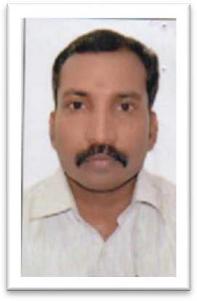

Plakkatu veedu, Arkkanoor P.O Arkkanoor , Ayur, Kollam (Dist) Kerala Pin:-691533

8943616633

bijunayur33@gmail.com
 | Sex Male | Date of birth 07/02/1980 | Nationality INDIAN

JOB APPLIED FOR  POSITION  PREFERRED JOB | TRUCK DRIVER

WORK EXPERIENCE

2010 to 2015  2015 to 2017  2017 to Present | Driver
2010 to 2015  2015 to 2017  2017 to Present | Worked as doctor’s driver in Sathyasai Hospital Kottarakkara
2010 to 2015  2015 to 2017  2017 to Present | Driver in Saudi Arabia  Worked in Saudi Arabia as a driver  Truck Driver  Working as truck driver in Indian Oil Corporation Cochin

EDUCATION

S.S.L.C from board of Public exam, Govt. of Kerala

PERSONAL SKILLS

Mother tongue(s) | Malayalam
Other language(s) | UNDERSTANDING |  | SPEAKING |  | WRITING
Other language(s) | Listening | Reading | Spoken interaction | Spoken production
English | Yes | Yes | Yes | Yes | Yes
Arabic | Yes | Yes | Yes | Yes | No
Hindi | Yes | Yes | Yes | Yes | Yes

ADDITIONAL INFORMATION

Passport Details  Driving License Details | U3356053  Issue Date : 10/03/2021  Date of Expiry :09/03/2031  Place of Issue: Trivandrum  Valid Indian License  License No : KL 25 20090001859  Valid from : 29-04-2009  Valid to : 03-01-2026

DECELARATION

I hereby declare that all the above-mentioned details are true and correct to the best of my knowledge.
BIJU N

